1-IGP
# Source: Chatgpt (GPT-5-Mini) at [1/18/2026]
IGP stands for Interior Gateway Protocol — it is a type of routing protocol used to exchange routing information within a single autonomous system (AS) or single administrative domain (such as an organization, company, or campus network).

🧠 Simple Definition:
# Source: Chatgpt (GPT-5-Mini) at [1/18/2026]
An IGP is a protocol that routers use to find the best path for data to travel within the same network or organization.

🔑 Purpose of IGP
# Source: Chatgpt (GPT-5-Mini) at [1/18/2026]
- Manages internal routing
- Allows routers to automatically discover and maintain paths
- Supports dynamic route updates (adapts to changes or failures)
- Works within a single AS (unlike BGP, which works between ASes)

🔗 Common IGP Protocols
# Source: Chatgpt (GPT-5-Mini) at [1/18/2026]
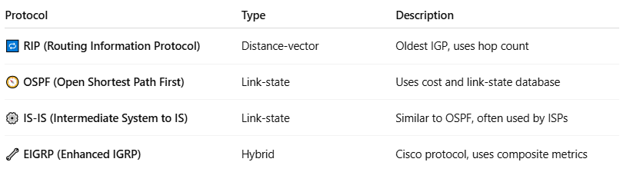

Protocol | Type | Description
🔁 RIP (Routing Information Protocol) | Distance-vector | Oldest IGP, uses hop count
🧭 OSPF (Open Shortest Path First) | Link-state | Uses cost and link-state database
⚙️ IS-IS (Intermediate System to IS) | Link-state | Similar to OSPF, often used by ISPs
🔧 EIGRP (Enhanced IGRP) | Hybrid | Cisco protocol, uses composite metrics

🔄 IGP vs EGP
# Source: Chatgpt (GPT-5-Mini) at [1/18/2026]
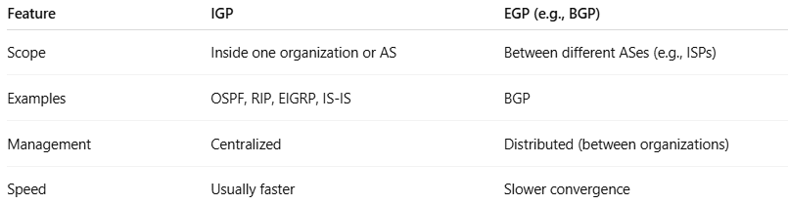

Feature | IGP | EGP (e.g., BGP)
Scope | Inside one organization or AS | Between different ASes (e.g., ISPs)
Examples | OSPF, RIP, EIGRP, IS-IS | BGP
Management | Centralized | Distributed (between organizations)
Speed | Usually faster | Slower convergence

✅ Summary
# Source: Chatgpt (GPT-5-Mini) at [1/18/2026]
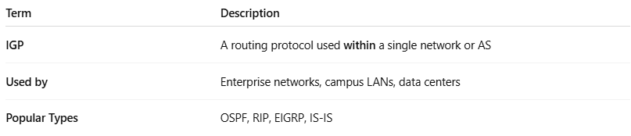

Term | Description
IGP | A routing protocol used within a single network or AS
Used by | Enterprise networks, campus LANs, data centers
Popular Types | OSPF, RIP, EIGRP, IS-IS

Would you like a comparison table of IGP protocols, or a diagram showing IGP inside and BGP outside an enterprise?

2-EGP
# Source: Chatgpt (GPT-5-Mini) at [1/18/2026]
EGP (Exterior Gateway Protocol) refers to a class of routing protocols used to exchange routing information between different Autonomous Systems (ASes) — that is, between networks managed by different organizations (e.g., between ISPs or between an enterprise and an ISP).

🧠 Simple Definition:
# Source: Chatgpt (GPT-5-Mini) at [1/18/2026]
An EGP allows routers in different networks (ASes) to communicate and exchange route information so data can travel across the global internet.

💡 EGP ≠ “the protocol” anymore
# Source: Chatgpt (GPT-5-Mini) at [1/18/2026]
While "EGP" was originally the name of an actual protocol (used in the early internet), today the term is used more generically to describe any inter-AS routing protocol.

🚀 Common EGP Today: BGP
# Source: Chatgpt (GPT-5-Mini) at [1/18/2026]
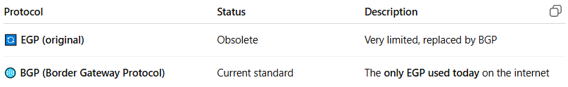

Protocol | Status | Description
🔄 EGP (original) | Obsolete | Very limited, replaced by BGP
🌐 BGP (Border Gateway Protocol) | Current standard | The only EGP used today on the internet

🔧 EGP vs IGP
# Source: Chatgpt (GPT-5-Mini) at [1/18/2026]
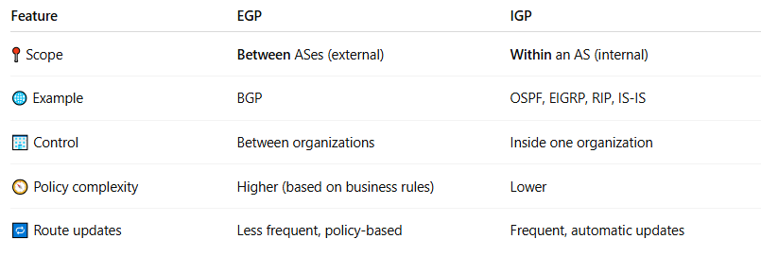

Feature | EGP | IGP
📍 Scope | Between ASes (external) | Within an AS (internal)
🌐 Example | BGP | OSPF, EIGRP, RIP, IS-IS
🏢 Control | Between organizations | Inside one organization
🧭 Policy complexity | Higher (based on business rules) | Lower
🔁 Route updates | Less frequent, policy-based | Frequent, automatic updates

🏢 Example Use Case
# Source: Chatgpt (GPT-5-Mini) at [1/18/2026]
If your company (AS64500) connects to two ISPs (AS64501 and AS64502), BGP (an EGP) decides which ISP to use for outgoing traffic or how to accept incoming traffic.
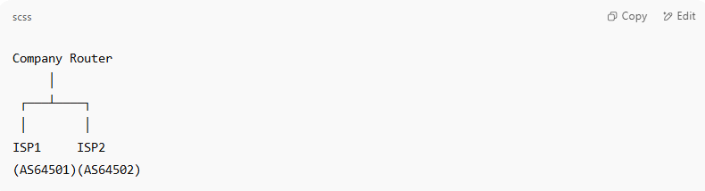
Company Router
│
┌───┴────┐
│ │
ISP1 ISP2
(AS64501)(AS64502)

Each connection uses BGP to exchange routing information between autonomous systems.

✅ Summary
# Source: Chatgpt (GPT-5-Mini) at [1/18/2026]
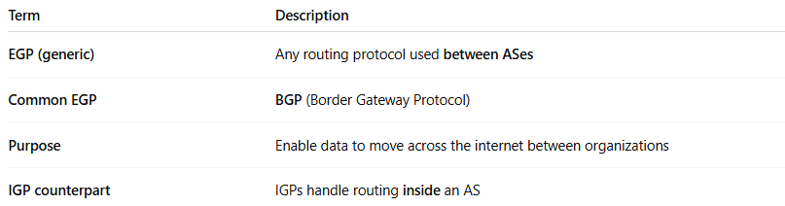

Term | Description
EGP (generic) | Any routing protocol used between ASes
Common EGP | BGP (Border Gateway Protocol)
Purpose | Enable data to move across the internet between organizations
IGP counterpart | IGPs handle routing inside an AS

3-RIP (Routing Information Protocol)
# Source: Chatgpt (GPT-5-Mini) at [1/18/2026]
RIP stands for Routing Information Protocol, and it's one of the oldest distance-vector routing protocols used in IP networks to determine the best path for data packets between routers.

🧠 Simple Definition:
# Source: Chatgpt (GPT-5-Mini) at [1/18/2026]
RIP is a dynamic routing protocol that uses hop count as its metric to choose the shortest path to a destination. The fewer hops (routers) a packet has to go through, the better the route is considered.

🔍 Key Features of RIP
# Source: Chatgpt (GPT-5-Mini) at [1/18/2026]
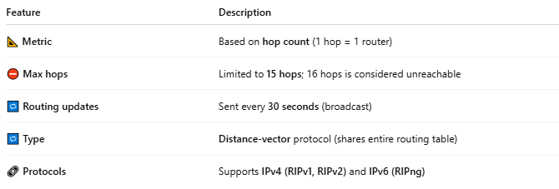

Feature | Description
📐 Metric | Based on hop count (1 hop = 1 router)
⛔ Max hops | Limited to 15 hops; 16 hops is considered unreachable
🔁 Routing updates | Sent every 30 seconds (broadcast)
🔁 Type | Distance-vector protocol (shares entire routing table)
🔗 Protocols | Supports IPv4 (RIPv1, RIPv2) and IPv6 (RIPng)

🛠️ How RIP Works
# Source: Chatgpt (GPT-5-Mini) at [1/18/2026]
- Each router maintains a routing table.
- It sends the table to its neighbors every 30 seconds.
- Neighbors compare paths and update their tables if a better path is found.
- The best path is chosen based on the lowest hop count.

📚 Versions of RIP
# Source: Chatgpt (GPT-5-Mini) at [1/18/2026]
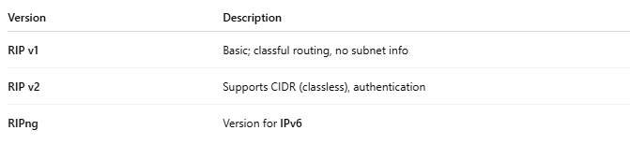

Version | Description
RIP v1 | Basic; classful routing, no subnet info
RIP v2 | Supports CIDR (classless), authentication
RIPng | Version for IPv6

✅ Advantages
# Source: Chatgpt (GPT-5-Mini) at [1/18/2026]
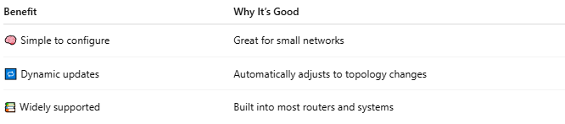

Benefit | Why It’s Good
🧠 Simple to configure | Great for small networks
🔁 Dynamic updates | Automatically adjusts to topology changes
📚 Widely supported | Built into most routers and systems

❌ Disadvantages
# Source: Chatgpt (GPT-5-Mini) at [1/18/2026]
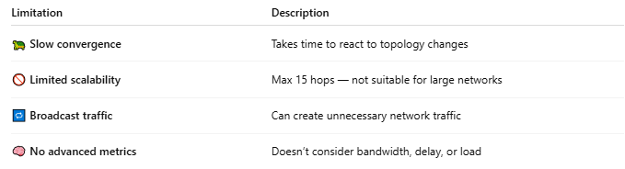

Limitation | Description
🐢 Slow convergence | Takes time to react to topology changes
🚫 Limited scalability | Max 15 hops — not suitable for large networks
🔁 Broadcast traffic | Can create unnecessary network traffic
🧠 No advanced metrics | Doesn’t consider bandwidth, delay, or load

🏢 When to Use RIP
# Source: Chatgpt (GPT-5-Mini) at [1/18/2026]
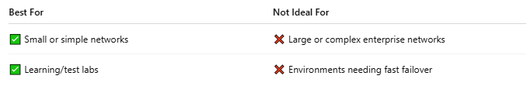

Best For | Not Ideal For
✅ Small or simple networks | ❌ Large or complex enterprise networks
✅ Learning/test labs | ❌ Environments needing fast failover

🧭 Example: RIP in Action
# Source: Chatgpt (GPT-5-Mini) at [1/18/2026]
A network with three routers:
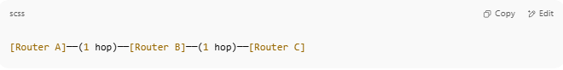
[Router A]──(1 hop)──[Router B]──(1 hop)──[Router C]

- Router A sees Router C as 2 hops away.
- If Router C goes down, RIP will update the routing tables within ~180 seconds.

✅ Summary
# Source: Chatgpt (GPT-5-Mini) at [1/18/2026]
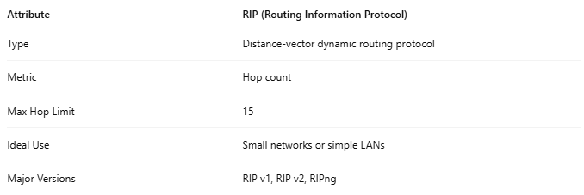

Attribute | RIP (Routing Information Protocol)
Type | Distance-vector dynamic routing protocol
Metric | Hop count
Max Hop Limit | 15
Ideal Use | Small networks or simple LANs
Major Versions | RIP v1, RIP v2, RIPng

4-OSPF
# Source: Chatgpt (GPT-5-Mini) at [1/18/2026]
OSPF is a widely used dynamic routing protocol that determines the best path for data to travel across IP networks using a link-state algorithm. Unlike RIP, which only counts hops, OSPF evaluates multiple factors like bandwidth and cost for more accurate routing.

🧠 Simple Definition:
# Source: Chatgpt (GPT-5-Mini) at [1/18/2026]
OSPF (Open Shortest Path First) is a link-state routing protocol that uses the Dijkstra algorithm to calculate the shortest and most efficient path to each destination in a network.

🔑 Key Features of OSPF
# Source: Chatgpt (GPT-5-Mini) at [1/18/2026]
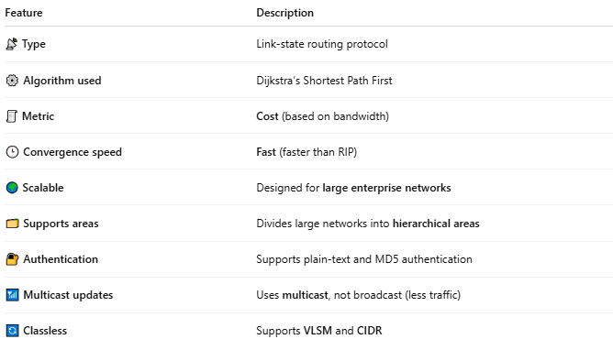

Feature | Description
📡 Type | Link-state routing protocol
⚙️ Algorithm used | Dijkstra’s Shortest Path First
🧾 Metric | Cost (based on bandwidth)
🕒 Convergence speed | Fast (faster than RIP)
🌍 Scalable | Designed for large enterprise networks
🗂️ Supports areas | Divides large networks into hierarchical areas
🔐 Authentication | Supports plain-text and MD5 authentication
📶 Multicast updates | Uses multicast, not broadcast (less traffic)
🔄 Classless | Supports VLSM and CIDR

🧭 How OSPF Works
# Source: Chatgpt (GPT-5-Mini) at [1/18/2026]
- Each router exchanges link-state advertisements (LSAs) with neighbors.
- Routers build a map of the network (link-state database).
- Each router runs Dijkstra’s algorithm to calculate the best path.
- Routing tables are updated accordingly.

🗺️ OSPF Areas
# Source: Chatgpt (GPT-5-Mini) at [1/18/2026]
- Backbone Area (Area 0): Core of all OSPF networks; all other areas must connect to it.
- Standard Areas: Regular routing areas (e.g., Area 1, Area 2).
- Stub Areas / NSSA: Optimize routing by limiting external route information.

✅ Advantages
# Source: Chatgpt (GPT-5-Mini) at [1/18/2026]
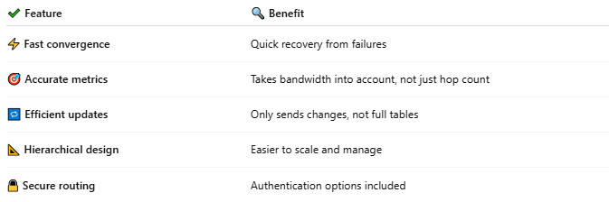
✔ Feature | 🔍 Benefit
⚡ Fast convergence | Quick recovery from failures
🎯 Accurate metrics | Takes bandwidth into account, not just hop count
🔁 Efficient updates | Only sends changes, not full tables
📐 Hierarchical design | Easier to scale and manage
🔒 Secure routing | Authentication options included

❌ Disadvantages
# Source: Chatgpt (GPT-5-Mini) at [1/18/2026]
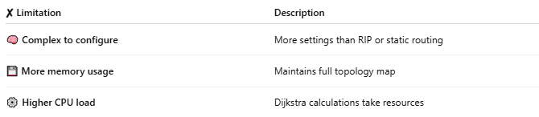
✘ Limitation | Description
🧠 Complex to configure | More settings than RIP or static routing
💾 More memory usage | Maintains full topology map
⚙️ Higher CPU load | Dijkstra calculations take resources

🏢 Common Use Cases
# Source: Chatgpt (GPT-5-Mini) at [1/18/2026]
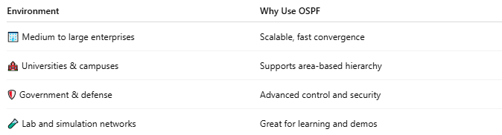
Environment | Why Use OSPF
🏢 Medium to large enterprises | Scalable, fast convergence
🏫 Universities & campuses | Supports area-based hierarchy
🛡️ Government & defense | Advanced control and security
🧪 Lab and simulation networks | Great for learning and demos

🔍 OSPF vs RIP
# Source: Chatgpt (GPT-5-Mini) at [1/18/2026]
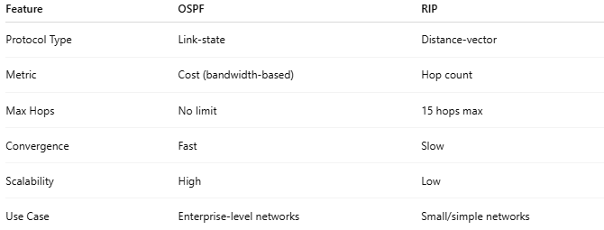
Feature | OSPF | RIP
Protocol Type | Link-state | Distance-vector
Metric | Cost (bandwidth-based) | Hop count
Max Hops | No limit | 15 hops max
Convergence | Fast | Slow
Scalability | High | Low
Use Case | Enterprise-level networks | Small/simple networks

✅ Summary
# Source: Chatgpt (GPT-5-Mini) at [1/18/2026]
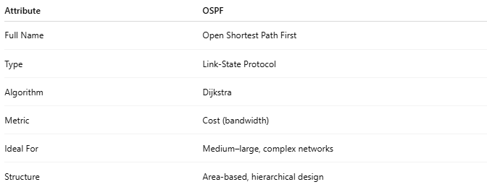

Attribute | OSPF
Full Name | Open Shortest Path First
Type | Link-State Protocol
Algorithm | Dijkstra
Metric | Cost (bandwidth)
Ideal For | Medium–large, complex networks
Structure | Area-based, hierarchical design

5-IS-IS
# Source: Chatgpt (GPT-5-Mini) at [1/18/2026]
IS-IS is a link-state Interior Gateway Protocol (IGP) used for routing within a single autonomous system (AS). It helps routers exchange information about network topology to determine the best path for data.

🧠 Simple Definition:
# Source: Chatgpt (GPT-5-Mini) at [1/18/2026]
IS-IS is a dynamic routing protocol, like OSPF, that routers use to learn the network layout and compute the shortest path for traffic using a link-state database.

🧩 Key Characteristics
# Source: Chatgpt (GPT-5-Mini) at [1/18/2026]
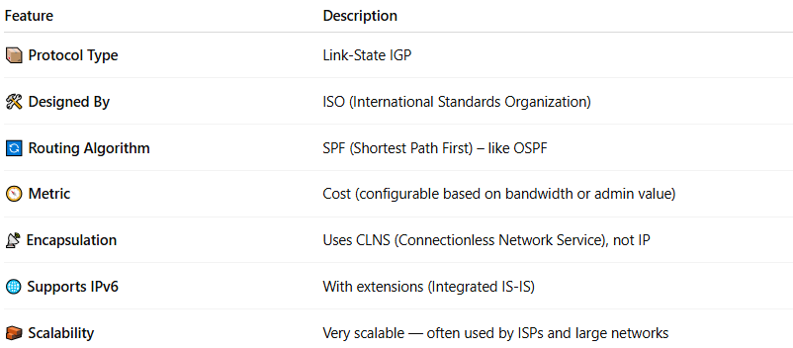

Feature | Description
📦 Protocol Type | Link-State IGP
🛠 Designed By | ISO (International Standards Organization)
🔄 Routing Algorithm | SPF (Shortest Path First) – like OSPF
🧭 Metric | Cost (configurable based on bandwidth or admin value)
📡 Encapsulation | Uses CLNS (Connectionless Network Service), not IP
🌐 Supports IPv6 | With extensions (Integrated IS-IS)
🧱 Scalability | Very scalable — often used by ISPs and large networks

🧠 IS-IS vs OSPF
# Source: Chatgpt (GPT-5-Mini) at [1/18/2026]
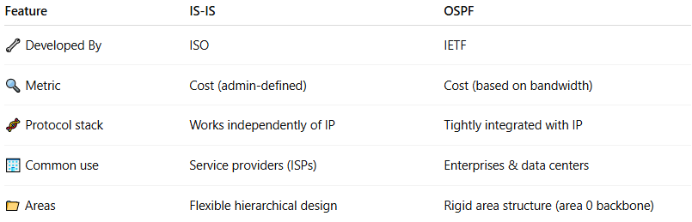

Feature | IS-IS | OSPF
🔧 Developed By | ISO | IETF
🔍 Metric | Cost (admin-defined) | Cost (based on bandwidth)
🧬 Protocol stack | Works independently of IP | Tightly integrated with IP
🏢 Common use | Service providers (ISPs) | Enterprises & data centers
📁 Areas | Flexible hierarchical design | Rigid area structure (area 0 backbone)

🏗️ How It Works
# Source: Chatgpt (GPT-5-Mini) at [1/18/2026]
- Routers send Link State PDUs (LSPs) to advertise connectivity.
- Each router builds a link-state database from LSPs.
- They run the SPF (Dijkstra’s Algorithm) to calculate the best path.
- Changes are quickly propagated when network topology updates.

🔄 IS-IS Hierarchy
# Source: Chatgpt (GPT-5-Mini) at [1/18/2026]
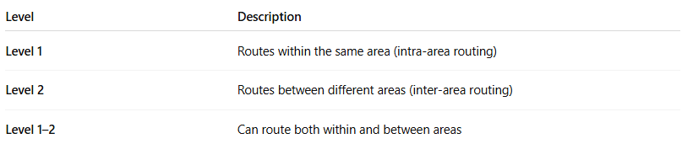

Level | Description
Level 1 | Routes within the same area (intra-area routing)
Level 2 | Routes between different areas (inter-area routing)
Level 1–2 | Can route both within and between areas

✅ Advantages
# Source: Chatgpt (GPT-5-Mini) at [1/18/2026]
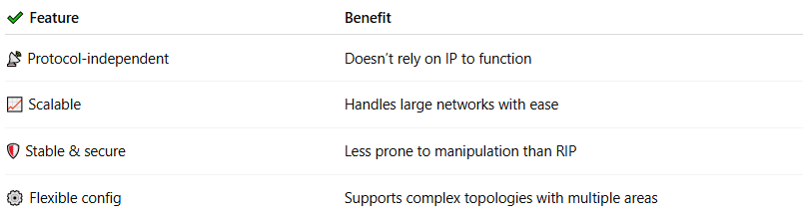

✔ Feature | Benefit
📡 Protocol-independent | Doesn’t rely on IP to function
📈 Scalable | Handles large networks with ease
🛡 Stable & secure | Less prone to manipulation than RIP
⚙ Flexible config | Supports complex topologies with multiple areas

❌ Disadvantages
# Source: Chatgpt (GPT-5-Mini) at [1/18/2026]
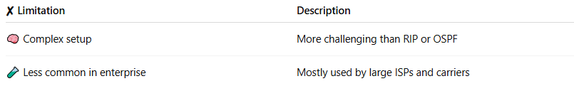

✘ Limitation | Description
🧠 Complex setup | More challenging than RIP or OSPF
🧪 Less common in enterprise | Mostly used by large ISPs and carriers

🏢 Used By:
# Source: Chatgpt (GPT-5-Mini) at [1/18/2026]
- Large ISPs (e.g., Verizon, AT&T)
- Backbone routers in telco networks
- Cloud providers and large-scale data centers

✅ Summary
# Source: Chatgpt (GPT-5-Mini) at [1/18/2026]
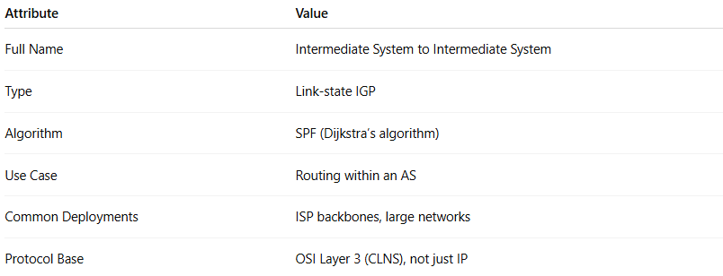

Attribute | Value
Full Name | Intermediate System to Intermediate System
Type | Link-state IGP
Algorithm | SPF (Dijkstra’s algorithm)
Use Case | Routing within an AS
Common Deployments | ISP backbones, large networks
Protocol Base | OSI Layer 3 (CLNS), not just IP

6-BGP
# Source: Chatgpt (GPT-5-Mini) at [1/18/2026]
BGP, or Border Gateway Protocol, is the main routing protocol of the internet. It is used to exchange routing information between different networks (called Autonomous Systems, or ASes), making it essential for connecting ISPs, data centers, cloud providers, and large enterprises.

🧠 Simple Definition:
# Source: Chatgpt (GPT-5-Mini) at [1/18/2026]
BGP is a path-vector routing protocol that determines the best route between autonomous systems (AS) on the internet based on policies, attributes, and path information, not just shortest distance.

🌐 Real-World Analogy:
# Source: Chatgpt (GPT-5-Mini) at [1/18/2026]
If the internet were a global highway system, BGP would be the traffic control center that tells data which highway to take between different countries (networks/ASes), based on rules, agreements, and performance — not just distance.

🧭 Key Characteristics of BGP
# Source: Chatgpt (GPT-5-Mini) at [1/18/2026]
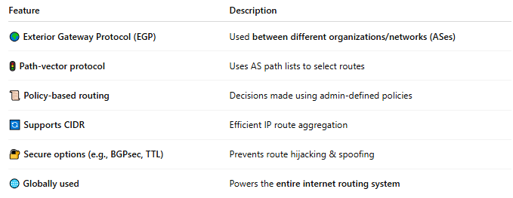

Feature | Description
🌍 Exterior Gateway Protocol (EGP) | Used between different organizations/networks (ASes)
🚦 Path-vector protocol | Uses AS path lists to select routes
📜 Policy-based routing | Decisions made using admin-defined policies
🔄 Supports CIDR | Efficient IP route aggregation
🔐 Secure options (e.g., BGPsec, TTL) | Prevents route hijacking & spoofing
🌐 Globally used | Powers the entire internet routing system

🔗 Types of BGP
# Source: Chatgpt (GPT-5-Mini) at [1/18/2026]
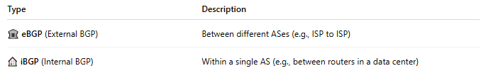

Type | Description
🏛 eBGP (External BGP) | Between different ASes (e.g., ISP to ISP)
🏠 iBGP (Internal BGP) | Within a single AS (e.g., between routers in a data center)

📊 How BGP Chooses Routes
# Source: Chatgpt (GPT-5-Mini) at [1/18/2026]
Unlike RIP or OSPF, BGP doesn’t use shortest path or bandwidth. It uses attributes like:
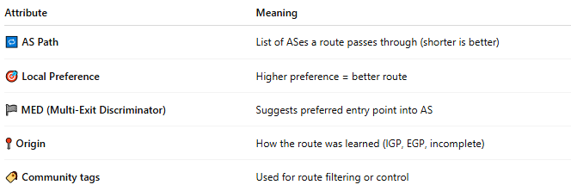
Attribute | Meaning
🔁 AS Path | List of ASes a route passes through (shorter is better)
🎯 Local Preference | Higher preference = better route
🏁 MED (Multi-Exit Discriminator) | Suggests preferred entry point into AS
📍 Origin | How the route was learned (IGP, EGP, incomplete)
🏷️ Community tags | Used for route filtering or control

✅ Advantages of BGP
# Source: Chatgpt (GPT-5-Mini) at [1/18/2026]
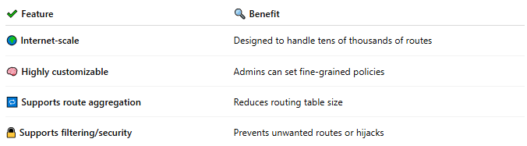

✔ Feature | 🔍 Benefit
🌍 Internet-scale | Designed to handle tens of thousands of routes
🧠 Highly customizable | Admins can set fine-grained policies
🔁 Supports route aggregation | Reduces routing table size
🔒 Supports filtering/security | Prevents unwanted routes or hijacks

❌ Disadvantages
# Source: Chatgpt (GPT-5-Mini) at [1/18/2026]
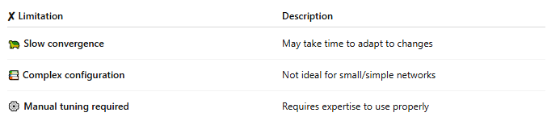

✘ Limitation | Description
🐢 Slow convergence | May take time to adapt to changes
📚 Complex configuration | Not ideal for small/simple networks
⚙️ Manual tuning required | Requires expertise to use properly

🏢 Common Use Cases
# Source: Chatgpt (GPT-5-Mini) at [1/18/2026]
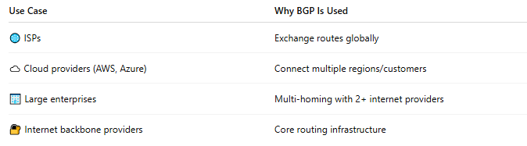

Use Case | Why BGP Is Used
🌐 ISPs | Exchange routes globally
☁️ Cloud providers (AWS, Azure) | Connect multiple regions/customers
🏢 Large enterprises | Multi-homing with 2+ internet providers
🔐 Internet backbone providers | Core routing infrastructure

🔍 BGP vs OSPF vs RIP
# Source: Chatgpt (GPT-5-Mini) at [1/18/2026]
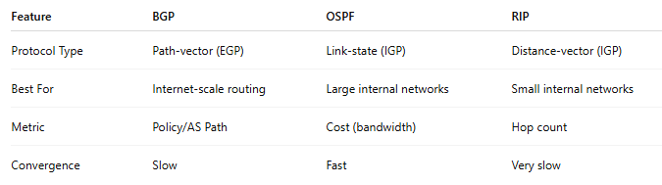

Feature | BGP | OSPF | RIP
Protocol Type | Path-vector (EGP) | Link-state (IGP) | Distance-vector (IGP)
Best For | Internet-scale routing | Large internal networks | Small internal networks
Metric | Policy/AS Path | Cost (bandwidth) | Hop count
Convergence | Slow | Fast | Very slow

✅ Summary
# Source: Chatgpt (GPT-5-Mini) at [1/18/2026]
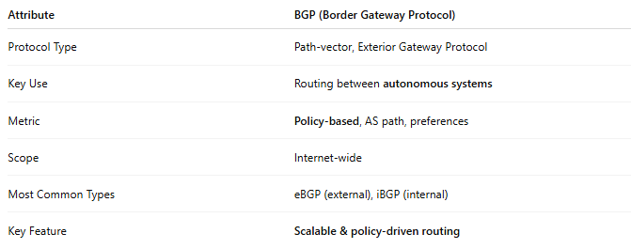

Attribute | BGP (Border Gateway Protocol)
Protocol Type | Path-vector, Exterior Gateway Protocol
Key Use | Routing between autonomous systems
Metric | Policy-based, AS path, preferences
Scope | Internet-wide
Most Common Types | eBGP (external), iBGP (internal)
Key Feature | Scalable & policy-driven routing

7-IGRP
# Source: Chatgpt (GPT-5-Mini) at [1/18/2026]
IGRP stands for Interior Gateway Routing Protocol — a distance-vector routing protocol developed by Cisco Systems in the 1980s for routing within an autonomous system (AS). It was designed to overcome the limitations of RIP, especially in larger networks.
🧠 Note: IGRP is now obsolete and has been replaced by EIGRP, its more powerful successor.

📌 Simple Definition:
# Source: Chatgpt (GPT-5-Mini) at [1/18/2026]
IGRP automatically determines the best path within a network by evaluating several metrics, such as bandwidth, delay, load, and reliability, instead of just hop count like RIP.

🧱 Key Characteristics of IGRP
# Source: Chatgpt (GPT-5-Mini) at [1/18/2026]
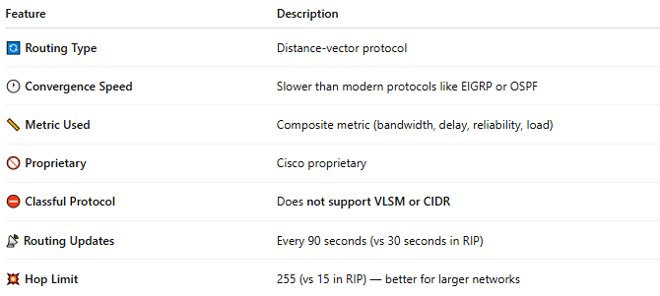

Feature | Description
🔄 Routing Type | Distance-vector protocol
🕐 Convergence Speed | Slower than modern protocols like EIGRP or OSPF
📏 Metric Used | Composite metric (bandwidth, delay, reliability, load)
🚫 Proprietary | Cisco proprietary
⛔ Classful Protocol | Does not support VLSM or CIDR
📡 Routing Updates | Every 90 seconds (vs 30 seconds in RIP)
💥 Hop Limit | 255 (vs 15 in RIP) — better for larger networks

⚙️ How IGRP Works
# Source: Chatgpt (GPT-5-Mini) at [1/18/2026]
- Each router sends its entire routing table to directly connected neighbors.
- Routes are evaluated based on a composite metric.
- The path with the lowest total metric is chosen as the best route.
- Updates occur every 90 seconds, helping reduce unnecessary traffic.

🧮 IGRP Metric Formula (Simplified)
# Source: Chatgpt (GPT-5-Mini) at [1/18/2026]
IGRP calculates a metric using:
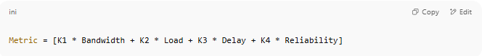
Metric = [K1 * Bandwidth + K2 * Load + K3 * Delay + K4 * Reliability]

(The actual formula is weighted with constants K1–K5, configurable by the administrator.)

✅ Advantages (in its time)
# Source: Chatgpt (GPT-5-Mini) at [1/18/2026]
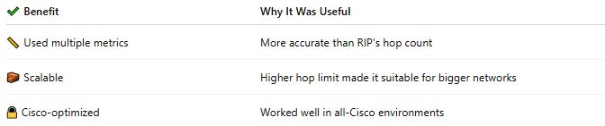

✔ Benefit | Why It Was Useful
📏 Used multiple metrics | More accurate than RIP's hop count
🧱 Scalable | Higher hop limit made it suitable for bigger networks
🔒 Cisco-optimized | Worked well in all-Cisco environments

❌ Disadvantages
# Source: Chatgpt (GPT-5-Mini) at [1/18/2026]
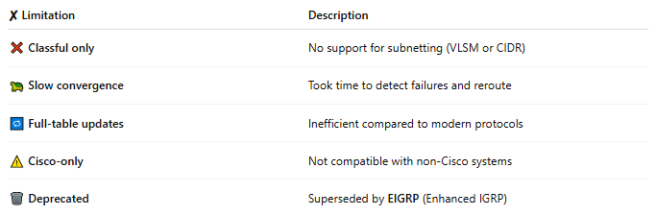

✘ Limitation | Description
❌ Classful only | No support for subnetting (VLSM or CIDR)
🐢 Slow convergence | Took time to detect failures and reroute
🔁 Full-table updates | Inefficient compared to modern protocols
⚠️ Cisco-only | Not compatible with non-Cisco systems
🗑️ Deprecated | Superseded by EIGRP (Enhanced IGRP)

🔁 IGRP vs EIGRP
# Source: Chatgpt (GPT-5-Mini) at [1/18/2026]
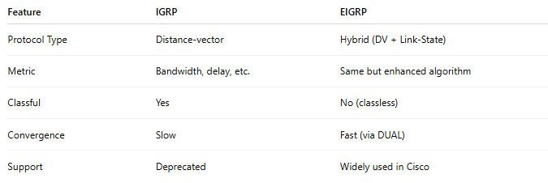

Feature | IGRP | EIGRP
Protocol Type | Distance-vector | Hybrid (DV + Link-State)
Metric | Bandwidth, delay, etc. | Same but enhanced algorithm
Classful | Yes | No (classless)
Convergence | Slow | Fast (via DUAL)
Support | Deprecated | Widely used in Cisco

✅ Summary
# Source: Chatgpt (GPT-5-Mini) at [1/18/2026]
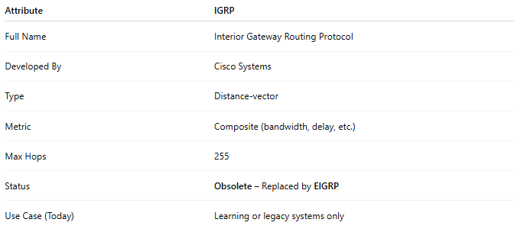

Attribute | IGRP
Full Name | Interior Gateway Routing Protocol
Developed By | Cisco Systems
Type | Distance-vector
Metric | Composite (bandwidth, delay, etc.)
Max Hops | 255
Status | Obsolete – Replaced by EIGRP
Use Case (Today) | Learning or legacy systems only

Would you like a timeline showing the evolution from RIP → IGRP → EIGRP → OSPF, or a comparison chart of all interior routing protocols?

8-EIGRP
# Source: Chatgpt (GPT-5-Mini) at [1/18/2026]
EIGRP is a dynamic routing protocol developed by Cisco. It’s an advanced version of the older IGRP and combines features of distance-vector and link-state protocols, making it a hybrid routing protocol.

🧠 Simple Definition:
# Source: Chatgpt (GPT-5-Mini) at [1/18/2026]
EIGRP automatically calculates the best path for data to travel within a network (within an autonomous system), using bandwidth, delay, reliability, and load as its routing metrics.

🔧 Key Characteristics
# Source: Chatgpt (GPT-5-Mini) at [1/18/2026]
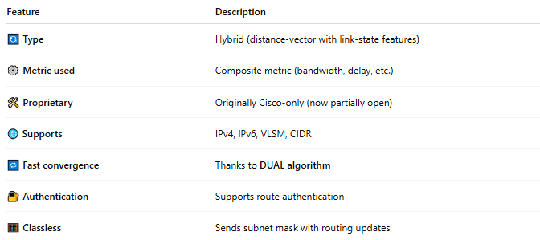

Feature | Description
🔄 Type | Hybrid (distance-vector with link-state features)
⚙️ Metric used | Composite metric (bandwidth, delay, etc.)
🛠 Proprietary | Originally Cisco-only (now partially open)
🌐 Supports | IPv4, IPv6, VLSM, CIDR
🔁 Fast convergence | Thanks to DUAL algorithm
🔐 Authentication | Supports route authentication
🧮 Classless | Sends subnet mask with routing updates

📈 How EIGRP Works
# Source: Chatgpt (GPT-5-Mini) at [1/18/2026]
- Routers form neighbor relationships by sending hello packets.
- They exchange routing tables.
- Each router runs the DUAL (Diffusing Update Algorithm) to determine:
  - Feasible successor (backup route)
  - Successor (best route)
- Only changes are sent — not full routing tables.

📦 Metric Components
# Source: Chatgpt (GPT-5-Mini) at [1/18/2026]
EIGRP uses a composite metric based on:
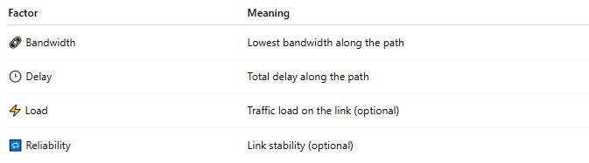
Factor | Meaning
🔗 Bandwidth | Lowest bandwidth along the path
🕒 Delay | Total delay along the path
⚡ Load | Traffic load on the link (optional)
🔁 Reliability | Link stability (optional)

✅ Advantages
# Source: Chatgpt (GPT-5-Mini) at [1/18/2026]
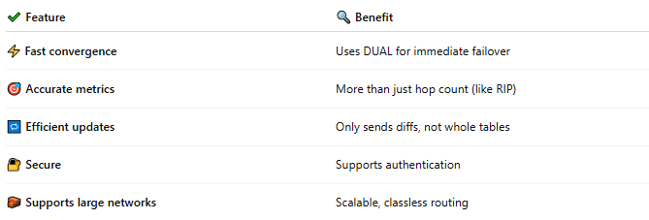

✔ Feature | 🔍 Benefit
⚡ Fast convergence | Uses DUAL for immediate failover
🎯 Accurate metrics | More than just hop count (like RIP)
🔁 Efficient updates | Only sends diffs, not whole tables
🔐 Secure | Supports authentication
🧱 Supports large networks | Scalable, classless routing

❌ Disadvantages
# Source: Chatgpt (GPT-5-Mini) at [1/18/2026]
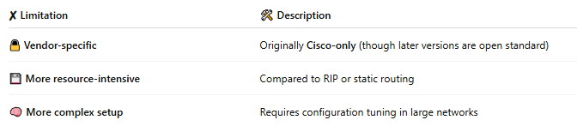

✘ Limitation | 🛠 Description
🔒 Vendor-specific | Originally Cisco-only (though later versions are open standard)
💾 More resource-intensive | Compared to RIP or static routing
🧠 More complex setup | Requires configuration tuning in large networks

🏢 Common Use Cases
# Source: Chatgpt (GPT-5-Mini) at [1/18/2026]
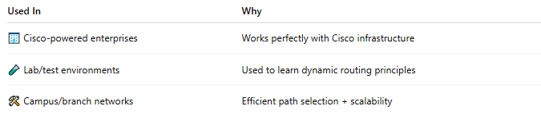

Used In | Why
🏢 Cisco-powered enterprises | Works perfectly with Cisco infrastructure
🧪 Lab/test environments | Used to learn dynamic routing principles
🛠 Campus/branch networks | Efficient path selection + scalability

📊 EIGRP vs OSPF vs RIP
# Source: Chatgpt (GPT-5-Mini) at [1/18/2026]
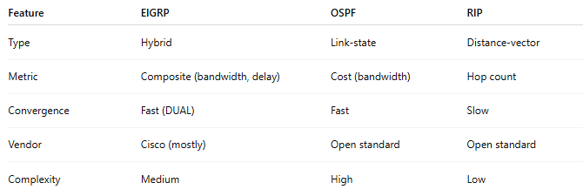

Feature | EIGRP | OSPF | RIP
Type | Hybrid | Link-state | Distance-vector
Metric | Composite (bandwidth, delay) | Cost (bandwidth) | Hop count
Convergence | Fast (DUAL) | Fast | Slow
Vendor | Cisco (mostly) | Open standard | Open standard
Complexity | Medium | High | Low

✅ Summary
# Source: Chatgpt (GPT-5-Mini) at [1/18/2026]
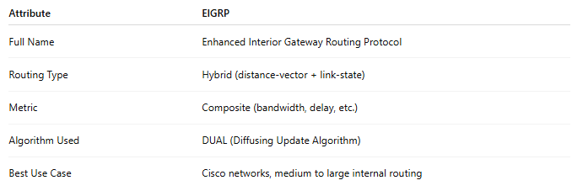

Attribute | EIGRP
Full Name | Enhanced Interior Gateway Routing Protocol
Routing Type | Hybrid (distance-vector + link-state)
Metric | Composite (bandwidth, delay, etc.)
Algorithm Used | DUAL (Diffusing Update Algorithm)
Best Use Case | Cisco networks, medium to large internal routing

